**Day 2 : Special Logic Building Assignment: 10 special Recursion Programs**

1. **Print 1 to n without using loops**

**Solution :**

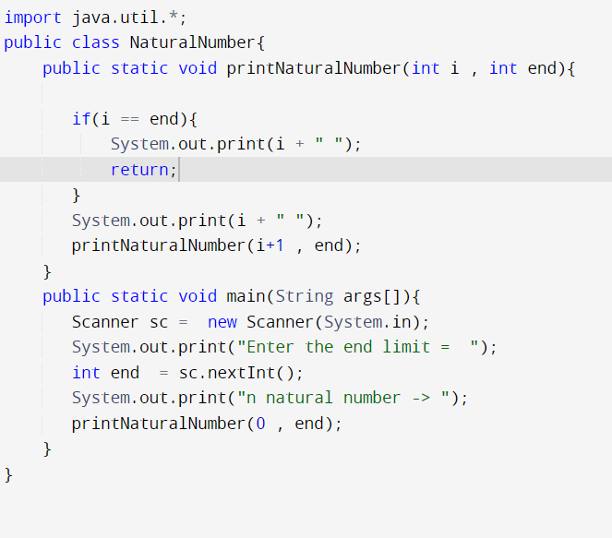

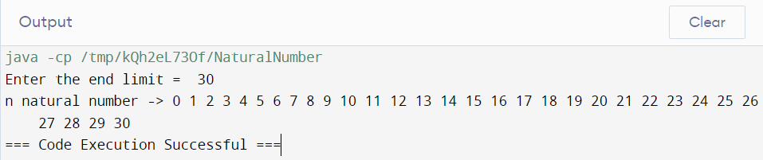

1. **Sum of natural numbers using recursion**

**Solution :**

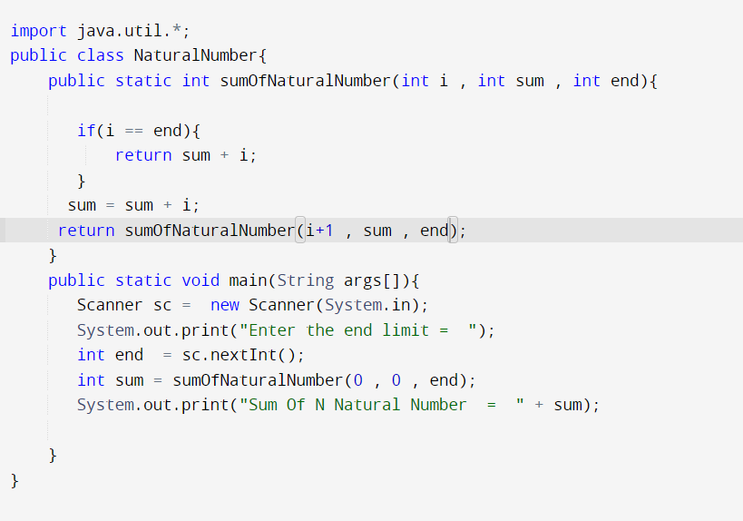

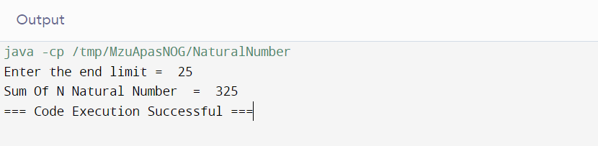

1. Mean of Array using Recursion

Solution : 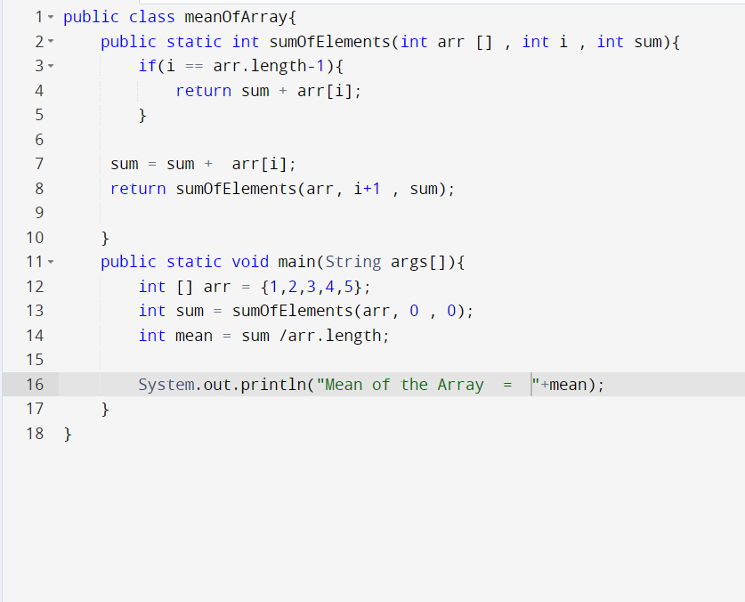

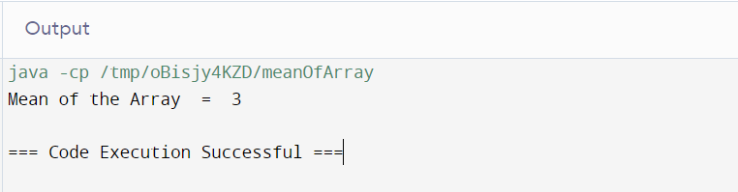

1. Sum of array elements using recursion

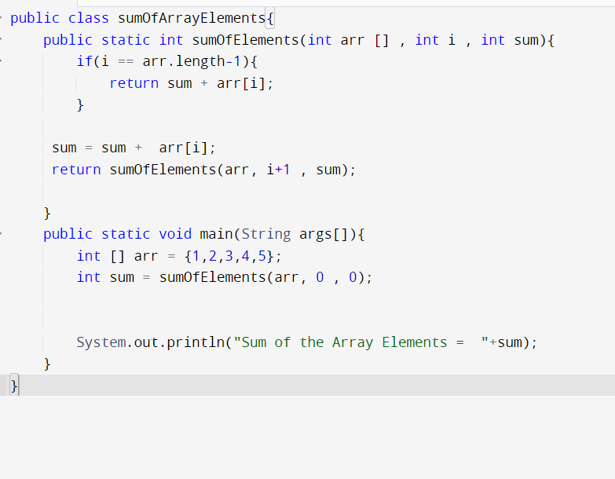

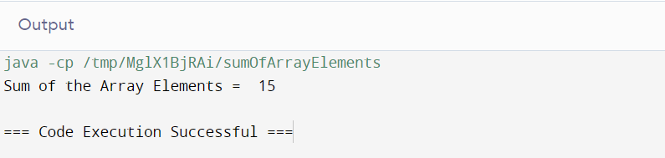

1. Decimal to binary number using recursion

Solution :

1. Sum of digit of a number using recursion

Solution :

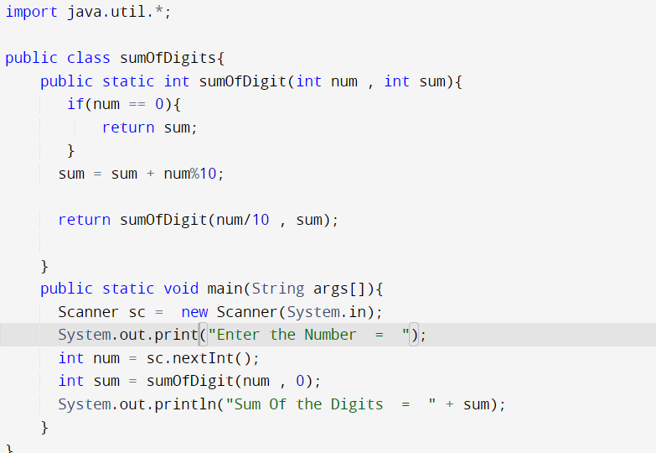

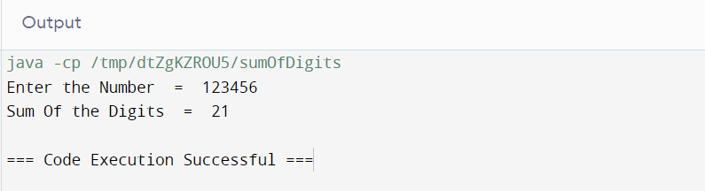

1. Print reverse of a string using recursion

Solution :

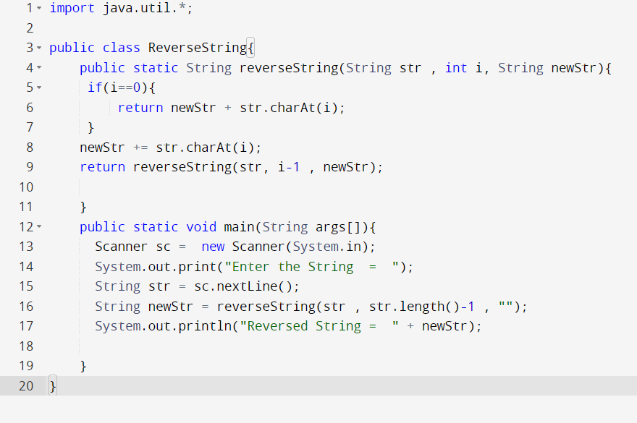

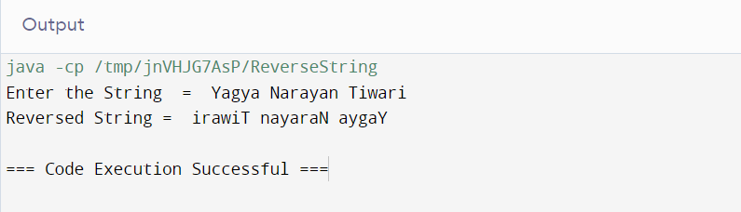

1. Program for length of a string using recursion

Solution :

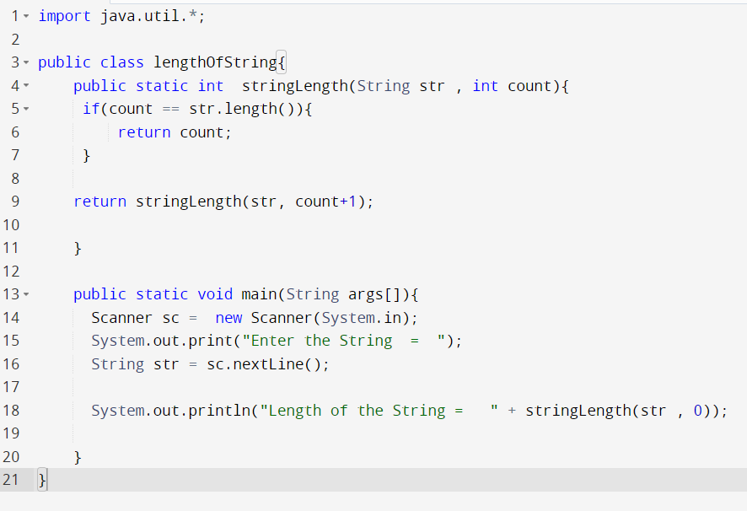

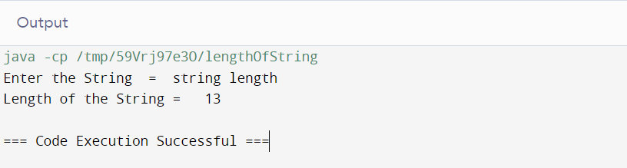

1. Tail recursion to calculate sum of array elements.

Solution :

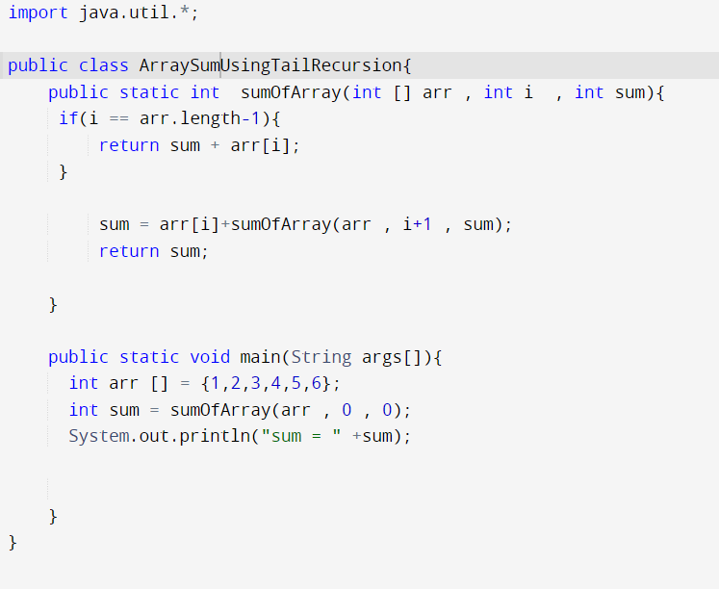

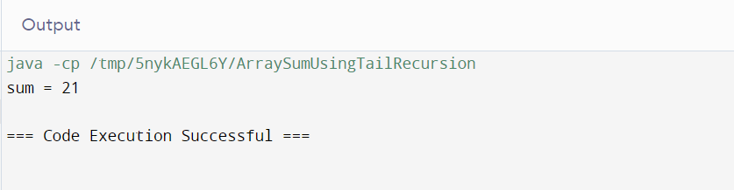

1. Recursive function to check if a string is palindrome

Solution :

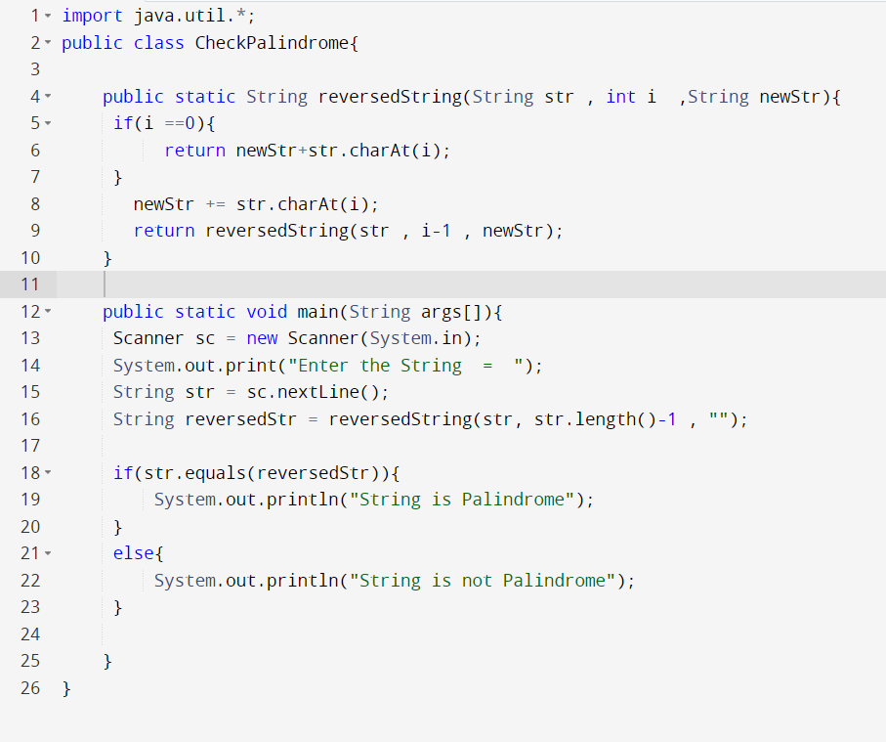

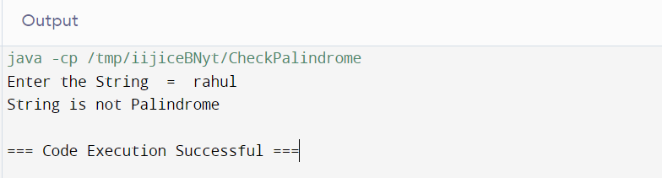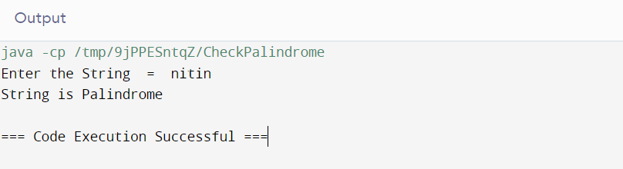

1. Print Fibonacci Series in reverse order using Recursion

Solution : 